**REACT**

**Hands On – 3**

Create a React Application “eventexamplesapp” to handle various events of the form elements in HTML.

Steps:

**App.js**

import React, { useState } from 'react';

import './App.css';

function CurrencyConvertor() {

  const [amount, setAmount] = useState('');

  const [currency, setCurrency] = useState('');

  const handleSubmit = (e) => {

    e.preventDefault();

    const converted = (amount / 90).toFixed(2); // Assuming 1 Euro = 90 INR

    alert(`Converted Amount in Euro: €${converted}`);

  };

  return (

    <div>

      <h2 style={{ color: 'green' }}>Currency Convertor!!!</h2>

      <form onSubmit={handleSubmit}>

        <label>

          Amount: <input type="text" value={amount} onChange={(e) => setAmount(e.target.value)} />

        </label><br /><br />

        <label>

          Currency: <textarea value={currency} onChange={(e) => setCurrency(e.target.value)} />

        </label><br /><br />

        <button type="submit">Submit</button>

      </form>

    </div>

  );

}

function App() {

  const [count, setCount] = useState(5);

  const increment = () => {

    setCount(prev => prev + 1);

    sayHello();

  };

  const decrement = () => {

    setCount(prev => prev - 1);

  };

  const sayHello = () => {

    console.log("Hello from Increment");

  };

  const sayWelcome = (msg) => {

    alert(msg);

  };

  const handleClick = (event) => {

    alert("I was clicked");

  };

  return (

    <div className="App">

      <p>{count}</p>

      <button onClick={increment}>Increment</button> &nbsp;

      <button onClick={decrement}>Decrement</button> &nbsp;

      <button onClick={() => sayWelcome("Welcome!")}>Say welcome</button> &nbsp;

      <button onClick={handleClick}>Click on me</button>

      <br /><br />

      <CurrencyConvertor />

    </div>

  );

}

export default App;

**Output :**

1. Create “Increment” button to increase the value of the counter and “Decrement” button to decrease the value of the counter. The “Increase” button should invoke multiple methods.
   1. To increment the value
   2. Say Hello followed by a static message.

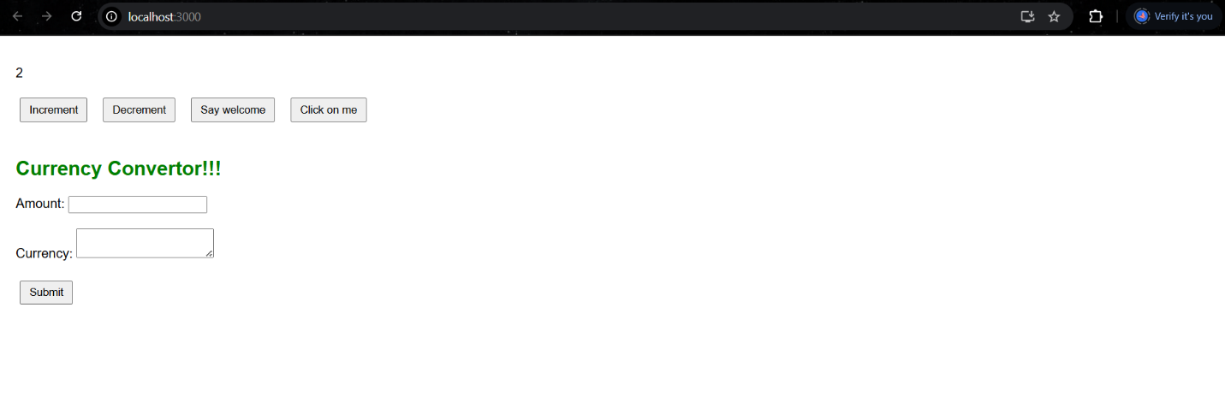

1. Create a button “Say Welcome” which invokes the function which takes “welcome” as an argument.

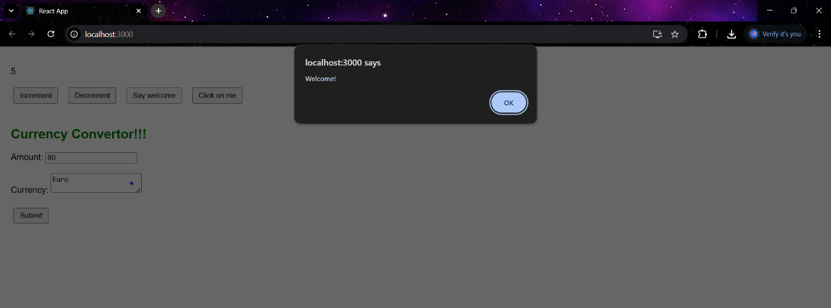

1. Create a button which invokes synthetic event “OnPress” which display “I was clicked”

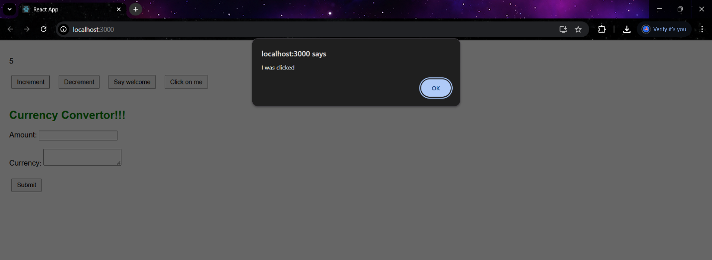

1. Create a “CurrencyConvertor” component which will convert the Indian Rupees to Euro when the Convert button is clicked.

